

Plan of attack

Ortho Eyes



8 oktober 2020

Minor applied data science

The Hague University of Applied Sciences

Table of contents

Introduction 2

Challenge 2

Cause 2

Target 3

Result 3

Planning 4

Scope 4

Consequences 5

Conditions 5

Risks 5

# Introduction

Over the past few years, different groups of students from the minor Applied Data Science have worked on the research on how to best classify patients with different gradients of shoulder injuries. In the next four months the research will be continued and expanded.

The product owner is A. Andrioli and the research is done for Jurriaan de Groot, who works at the Leiden University Medical Centre (LUMC).

This project group consists of six students from different studies at The Hague University of Applied Sciences: Donna van Grunsven, Tim Bekema, Beau Fiechter and Danny Vink from Software Engineering, Emma Korf from Mechatronics and Jasmijn Heupers from Applied Mathematics. The group is supported by teachers from different disciplines and they will work closely together with physiotherapy students from Leiden.

# Challenge

Last year the project group working on the Ortho Eyes project, of the minor Applied Data Science used data obtained by placing sensors on joints which take part in measuring shoulder movements with great accuracy. The results put forward by the project group last year established a clear distinction between two of the groups of test subjects, group one and three. The first group contains the individuals who do not have any shoulder injuries. People with significant disruptions in their shoulder motions were labelled as group three.

Last year A. Andrioli and J. Vuurens did research on how to classify patients in the correct patient group or control group with an accuracy great enough for it to be implemented in the medical field. Per movement the subjects were asked to execute, an individual model was made to examine specific features. The results per classifier were combined into an OR-ensemble to ensure that if a patient shows restricted moveability in their shoulder, the volunteer is classified as a patient. Even if they have no problem executing the remaining movements.

This semester we want to focus on researching features and models that can improve the recall of the current OR-ensemble. By improving the OR-ensemble we hope to perfect the method of determining the border that separates the four different patient groups.

In addition, after the process of classification it should be clear why the patient is appointed to the label. This is required because in the medical field the reasoning behind the classification is necessary to make a valid case, so a black box model would not be an option. So, the challenge for this semester is to find more features as meaningful additions to models which are combined to the OR-ensemble. This ensemble will classify the patients in an insightful way so that the reason for the classification is clear.

# Cause

As a follow-up to the previous delivered work, the project group will examine the impact and relevance of newly found features. By adjusting the gradient of the impact of the specific features in the measurements, the classification is perfected, and the additions of useless information can be disregarded. This optimizes the way the classification is established.

When classifications can be made with significant accuracy, the process in doing so can be used in the medical field. It can act as an easy way to determine if an individual has a shoulder injury, so a physiotherapist can make a precise diagnosis.

Our part in this project is hopefully going to be a great addition to the research and work that is already done and will be a next step in the direction of having a real contribution to medical practices. Ideally, the result of this minor will be a perfected version of an algorithm which can determine to which group an individual belongs to by analysing movement in daily habits. This is a long-term goal, in which we hope to make our contribution.

# Target

*Main research question*

Which models can be added to the current OR-ensemble to further improve the ability to properly identify individuals as part of the correct patient group, using the existing data gained from a Flock of Birds system?

*Sub-question 1*  
Based on the 3D animations from the Flock of Birds system, which features are promising for classifying shoulder injuries from a physiotherapeutic perspective?

*Sub-question 2*  
Based on the data from the Flock of Birds system, which features are promising for classifying shoulder injuries from a data science perspective?

*Sub-question 3*   
What is the certain added value of the parameters that were chosen in addition to the existing ensemble?

*Sub-question 4*  
Which classification models fit best with the chosen features?

*Sub-question 5*  
How do patients refrain certain parts of movements and how can this be recognized in the dataset?

# Result

We will gain further insight in concluding the main question by answering the above sub-questions. This is done in the form of a paper, which is handed in to the relevant lecturers at the end of the minor. In between, weekly presentations will be given to keep teachers and fellow students informed of our progress and the techniques learned.

# Planning

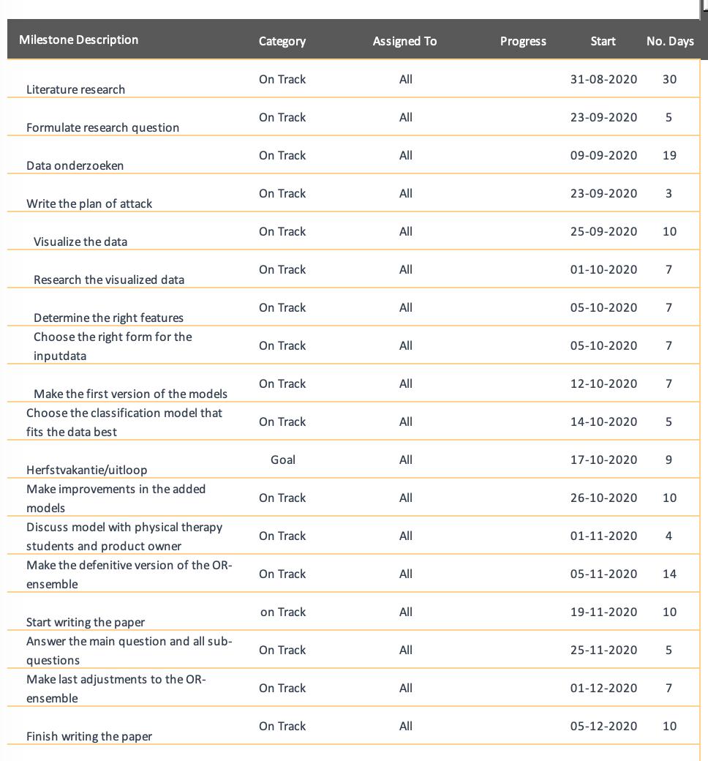

# Scope

We are using the existing dataset, gained from the Flock of Birds system. We are primarily using the data from the txt-files, which include the positional data and the rotation matrices. Initially, we intend to try to classify patients in the four existing patient groups. When we don’t find good results, we intend to classify patients solely in group 1 or group 3.

# Consequences

This project should be of value to either Juriaan de Groot and his research-team, or Jeroen Vuurens and Anthony Andrioli for their ongoing research. Previous executions of this project have not been that successful in identifying the different patient categories. Our results should present either a ‘better' model for identifying the categories, better format of data to be used by the model, or both. This in such a way that the results of exercise assessments are of value to a medical expert, or the results of testing the model are of value to continuation of the project.

# Conditions

Before delivering the resulting paper for this research project, it is of value that some sub-results are present for the project group, such that the writing of the paper can be done in a rather efficient way.

For this to be done, we need to answer all the research’s sub-questions.

# Risks

There are numerous risks involved in the Ortho Eyes project, some of which shall be discussed in this paragraph. The research completed by the previous groups were either inadequate in their findings due to some errors in their research and/or approach of the goal. For the current Ortho Eyes group, it is necessary to identify these risks before analysing the dataset.

One of the main points of critique was that previous groups contributed no added value to the medical sector. Previous models were able to classify data to some degree, however they were not medically justified. We hope to mitigate this risk by discussing our plans in an early stadium with the physiotherapy students and Juriaan de Groot. Additionally, we will try to align our project as much as possible with the physiotherapy students of the University of Applied Sciences in Leiden.

Lastly, in order to improve the current classification model, we need to be careful to not multiply any existing errors in the data. For example, if we input any wrong parameters this will snowball into a large-scale error.